ELEMENTS OF A HEALTHY COMMUNITY

 | Promotes leadership to address community challenges. (July ‘25)  A healthy community contains leaders who encourage participation and collaboration across sectors and groups to address community challenges to create positive change.
 | Encourages active civic engagement by its citizens. (August ‘25)  A healthy community promotes the active involvement in the civic life of the community through volunteering, and participation in public decision-making processes while ensuring that all community voices are heard and valued.
 | Ensures a vibrant and diversified economy. (September ‘25)  A healthy community fosters an economy that is diverse, vital, and innovative, grows strong businesses and business districts, and creates adequate jobs and income for residents.
 | Meets the basic needs of residents. (October ‘25)  A healthy community creates a compassionate social, economic, and political environment where people have full opportunities to meet basic needs for themselves and their families, to build assets, and to advance themselves.
 | Provides broad access to arts and culture. (November ‘25)  A healthy community encourages a wide variety of artistic, recreational, historical and cultural opportunities.
 | Promotes health and wellness. (December ‘25)  A healthy community assures access to high-quality health services on a personal, community, and systems-level and promotes a healthy lifestyle.

 | Ensures the public safety of its residents. (January ‘26)  A healthy community maintains safe physical environments and promotes policies that prevent harm and support rapid response in times of crisis.
 | Creates quality education and learning opportunities for all ages. (February‘26)  A healthy community opens itself to new ideas and provides high-quality education and life-long learning for all members of the community.
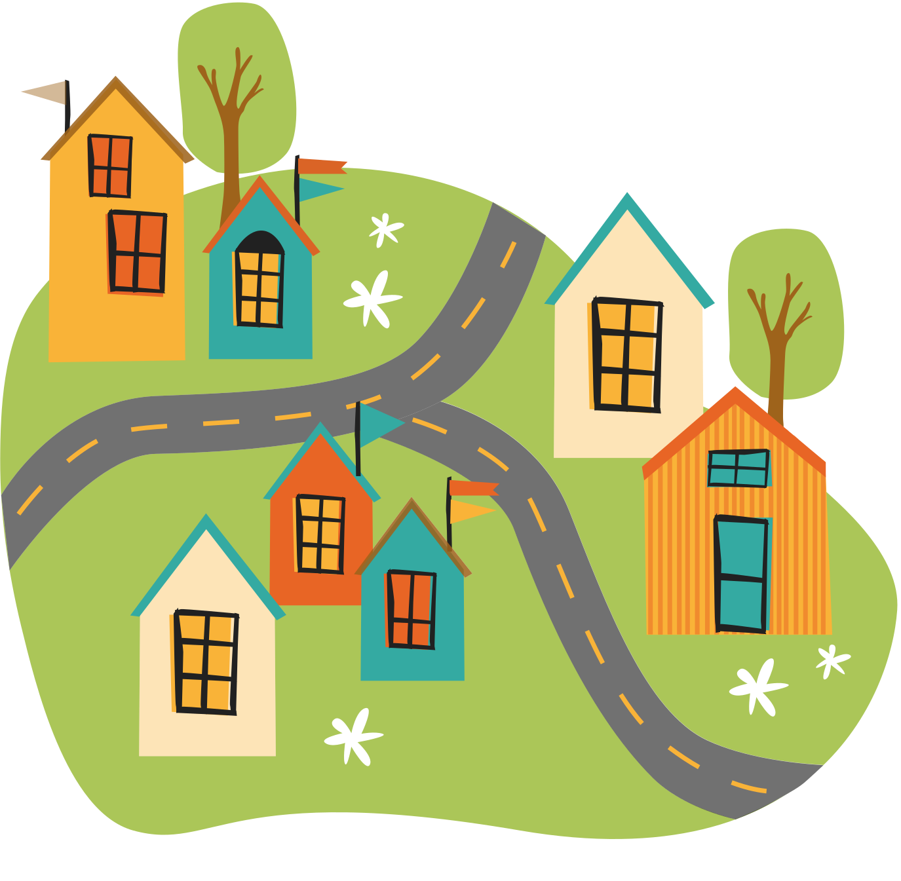 | Fosters strong and connected neighborhoods and communities. (March ‘26)  A healthy community assures equal opportunity for all individuals to participate in and influence decisions that affect and promote a “sense of community.”
 | Encourages responsibility for global citizenship. (April ‘26)  A healthy community encourages active participation in addressing global issues by recognizing the interconnectedness of communities worldwide.
 | Protects and stewards the natural environment. (May ‘26)  A healthy community helps preserve and sustain the environment including the surroundings that are essential for health and well-being, such as green spaces, habitats, air, water, soil quality, and biodiversity.
 | Works to build healthy communities. (June ’26)  A healthy community supports the well-being of all residents, offering access to essential services, opportunities for growth, and safe, nurturing environments that foster physical, mental, and social health.

